Pràctica 7.2 OLED SSD1306 en Arduino
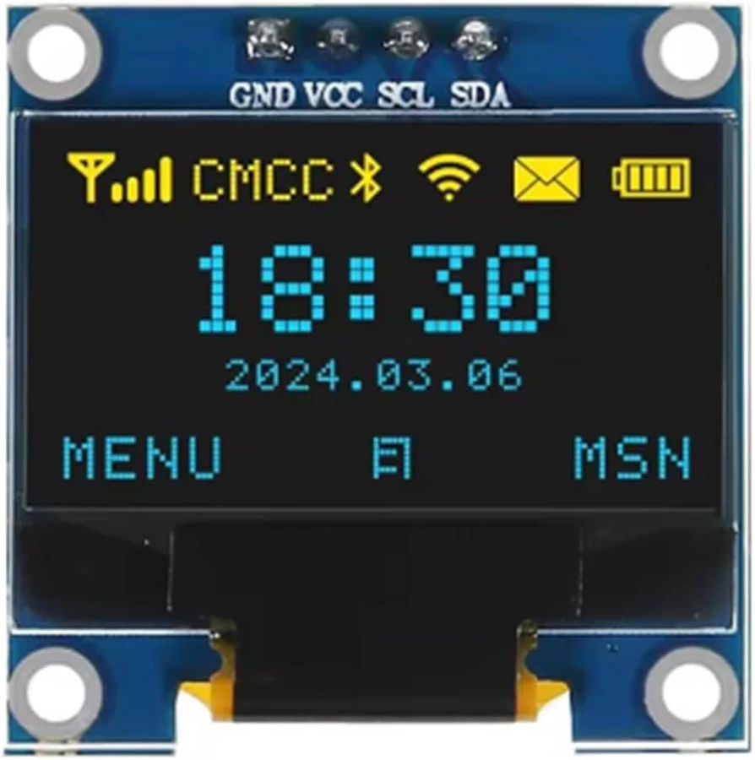
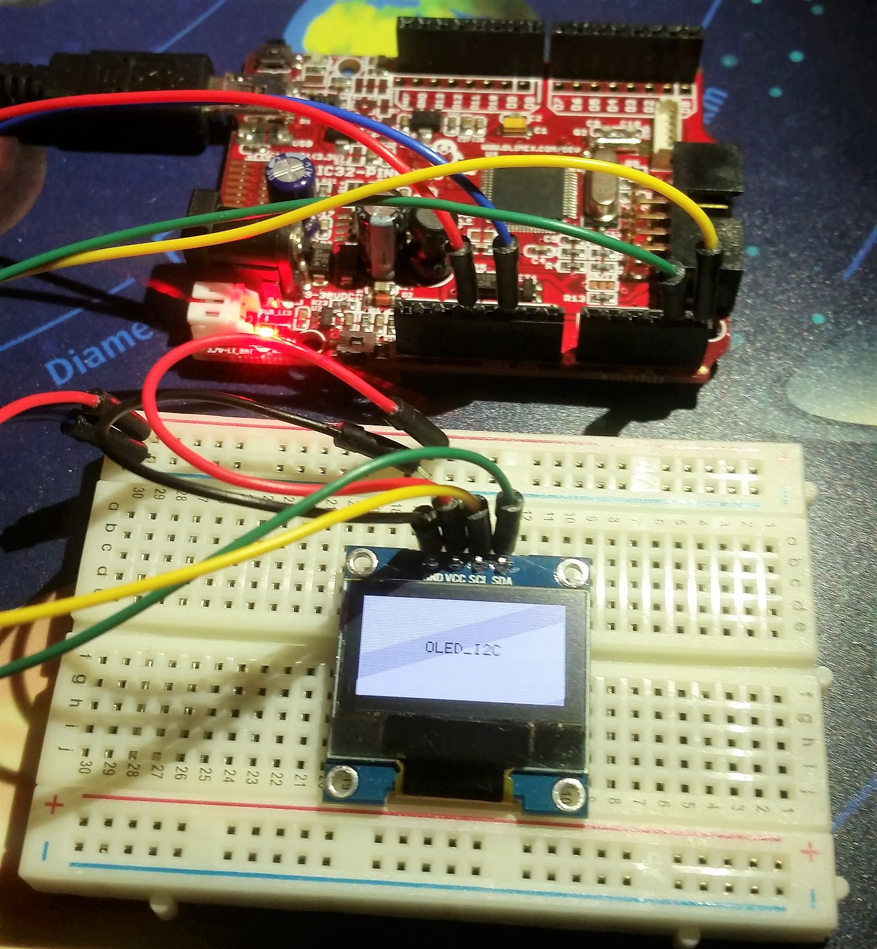

Per programar una pantalla OLED amb controlador Arduino SSD1306 en Arduino, el més habitual és utilitzar una pantalla I2C de 128×64 píxels amb les llibreries d’Adafruit.

Què necessites
- Arduino Uno, Nano, Mega, ESP32, etc.
- Pantalla OLED SSD1306 (normalment I2C)
- Llibreries:
  - Adafruit SSD1306
  - Adafruit GFX

Connexions típiques (I2C)

Arduino Uno / Nano
OLED | Arduino
VCC | 5V
GND | GND
SCL | A5
SDA | A4

ESP32
OLED | ESP32
VCC | 3.3V
GND | GND
SCL | GPIO 22
SDA | GPIO 21

Instal·lar les llibreries
En l’IDE d’Arduino:
- Programa → Incloure llibreria → Gestionar biblioteques
- Busca i instal·la:
  - “Adafruit SSD1306”
  - “Adafruit GFX Library”
També pots consultar la documentació oficial:
- Adafruit SSD1306 Library
- Adafruit GFX Library

Exemple bàsic de codi
#include <Wire.h>
#include <Adafruit_GFX.h>
#include <Adafruit_SSD1306.h>
#define SCREEN_WIDTH 128
#define SCREEN_HEIGHT 64
// Direcció I2C típica: 0x3C
#define OLED_ADDR 0x3C
Adafruit_SSD1306 display(SCREEN_WIDTH, SCREEN_HEIGHT, &Wire, -1);
void setup() {
Serial.begin(115200);
// Inicialitzar la pantalla
if(!display.begin(SSD1306_SWITCHCAPVCC, OLED_ADDR)) {
Serial.println("No s'ha trobat la pantalla OLED");
while(true);
}
// Netejar el buffer
display.clearDisplay();
// Grandària del text
display.setTextSize(2);
// Color del text
display.setTextColor(SSD1306_WHITE);
// Posició
display.setCursor(10, 20);
// Escriure text
display.println("Hola!");
// Mostrar en pantalla
display.display();
}
void loop() {
}

Què fa este codi
- Inicialitza la pantalla OLED
- Neteja la memòria gràfica
- Escriu “Hola!”
- Mostra el contingut en pantalla

Funcions útils

Escriure text
display.setTextSize(1);
display.setCursor(0,0);
display.println("Text");

Dibuixar línies
display.drawLine(0, 0, 127, 63, SSD1306_WHITE);

Dibuixar rectangles
display.drawRect(10, 10, 50, 30, SSD1306_WHITE);

Dibuixar cercles
display.drawCircle(64, 32, 20, SSD1306_WHITE);

Actualitzar la pantalla
display.display();

Netejar la pantalla
display.clearDisplay();

Escanejar l’adreça I2C
Si la pantalla no funciona, potser utilitza una altra adreça (0x3D en lloc de 0x3C).
Utilitza este escàner I2C:
#include <Wire.h>
void setup() {
Wire.begin();
Serial.begin(115200);
Serial.println("Escanejant I2C...");
for(byte addr = 1; addr < 127; addr++) {
Wire.beginTransmission(addr);
if(Wire.endTransmission() == 0) {
Serial.print("Trobat: 0x");
Serial.println(addr, HEX);
}
}
}
void loop() {}

Exemple amb animació
void loop() {
display.clearDisplay();
static int x = 0;
display.fillCircle(x, 32, 10, SSD1306_WHITE);
display.display();
x++;
if(x > 128)
x = 0;
delay(20);
}

Ves a GitHub i prova els exemples que venen amb les llibraries incloses en el repositori de Adafruit_SSD1306

/**************************************************************************
This is an example for our Monochrome OLEDs based on SSD1306 drivers

Pick one up today in the adafruit shop!
------> http://www.adafruit.com/category/63_98

This example is for a 128x32 pixel display using I2C to communicate
3 pins are required to interface (two I2C and one reset).

Adafruit invests time and resources providing this open
source code, please support Adafruit and open-source
hardware by purchasing products from Adafruit!

Written by Limor Fried/Ladyada for Adafruit Industries,
with contributions from the open source community.
BSD license, check license.txt for more information
All text above, and the splash screen below must be
included in any redistribution.
**************************************************************************/

#include <SPI.h>
#include <Wire.h>
#include <Adafruit_GFX.h>
#include <Adafruit_SSD1306.h>

#define SCREEN_WIDTH 128 // OLED display width, in pixels
#define SCREEN_HEIGHT 32 // OLED display height, in pixels

// Declaration for an SSD1306 display connected to I2C (SDA, SCL pins)
// The pins for I2C are defined by the Wire-library.
// On an arduino UNO: A4(SDA), A5(SCL)
// On an arduino MEGA 2560: 20(SDA), 21(SCL)
// On an arduino LEONARDO: 2(SDA), 3(SCL), ...
#define OLED_RESET -1 // Reset pin # (or -1 if sharing Arduino reset pin)
#define SCREEN_ADDRESS 0x3C ///< See datasheet for Address; 0x3D for 128x64, 0x3C for 128x32
Adafruit_SSD1306 display(SCREEN_WIDTH, SCREEN_HEIGHT, &Wire, OLED_RESET);

#define NUMFLAKES 10 // Number of snowflakes in the animation example

#define LOGO_HEIGHT 16
#define LOGO_WIDTH 16
static const unsigned char PROGMEM logo_bmp[] =
{ 0b00000000, 0b11000000,
0b00000001, 0b11000000,
0b00000001, 0b11000000,
0b00000011, 0b11100000,
0b11110011, 0b11100000,
0b11111110, 0b11111000,
0b01111110, 0b11111111,
0b00110011, 0b10011111,
0b00011111, 0b11111100,
0b00001101, 0b01110000,
0b00011011, 0b10100000,
0b00111111, 0b11100000,
0b00111111, 0b11110000,
0b01111100, 0b11110000,
0b01110000, 0b01110000,
0b00000000, 0b00110000 };

void setup() {
Serial.begin(9600);

// Wait for display
delay(500);

// SSD1306_SWITCHCAPVCC = generate display voltage from 3.3V internally
if(!display.begin(SSD1306_SWITCHCAPVCC, SCREEN_ADDRESS)) {
Serial.println(F("SSD1306 allocation failed"));
for(;;); // Don't proceed, loop forever
}

// Show initial display buffer contents on the screen --
// the library initializes this with an Adafruit splash screen.
display.display();
delay(2000); // Pause for 2 seconds

// Clear the buffer
display.clearDisplay();

// Draw a single pixel in white
display.drawPixel(10, 10, SSD1306_WHITE);

// Show the display buffer on the screen. You MUST call display() after
// drawing commands to make them visible on screen!
display.display();
delay(2000);
// display.display() is NOT necessary after every single drawing command,
// unless that's what you want...rather, you can batch up a bunch of
// drawing operations and then update the screen all at once by calling
// display.display(). These examples demonstrate both approaches...

testdrawline(); // Draw many lines

testdrawrect(); // Draw rectangles (outlines)

testfillrect(); // Draw rectangles (filled)

testdrawcircle(); // Draw circles (outlines)

testfillcircle(); // Draw circles (filled)

testdrawroundrect(); // Draw rounded rectangles (outlines)

testfillroundrect(); // Draw rounded rectangles (filled)

testdrawtriangle(); // Draw triangles (outlines)

testfilltriangle(); // Draw triangles (filled)

testdrawchar(); // Draw characters of the default font

testdrawstyles(); // Draw 'stylized' characters

testscrolltext(); // Draw scrolling text

testdrawbitmap(); // Draw a small bitmap image

// Invert and restore display, pausing in-between
display.invertDisplay(true);
delay(1000);
display.invertDisplay(false);
delay(1000);

testanimate(logo_bmp, LOGO_WIDTH, LOGO_HEIGHT); // Animate bitmaps
}

void loop() {
}

void testdrawline() {
int16_t i;

display.clearDisplay(); // Clear display buffer

for(i=0; i<display.width(); i+=4) {
display.drawLine(0, 0, i, display.height()-1, SSD1306_WHITE);
display.display(); // Update screen with each newly-drawn line
delay(1);
}
for(i=0; i<display.height(); i+=4) {
display.drawLine(0, 0, display.width()-1, i, SSD1306_WHITE);
display.display();
delay(1);
}
delay(250);

display.clearDisplay();

for(i=0; i<display.width(); i+=4) {
display.drawLine(0, display.height()-1, i, 0, SSD1306_WHITE);
display.display();
delay(1);
}
for(i=display.height()-1; i>=0; i-=4) {
display.drawLine(0, display.height()-1, display.width()-1, i, SSD1306_WHITE);
display.display();
delay(1);
}
delay(250);

display.clearDisplay();

for(i=display.width()-1; i>=0; i-=4) {
display.drawLine(display.width()-1, display.height()-1, i, 0, SSD1306_WHITE);
display.display();
delay(1);
}
for(i=display.height()-1; i>=0; i-=4) {
display.drawLine(display.width()-1, display.height()-1, 0, i, SSD1306_WHITE);
display.display();
delay(1);
}
delay(250);

display.clearDisplay();

for(i=0; i<display.height(); i+=4) {
display.drawLine(display.width()-1, 0, 0, i, SSD1306_WHITE);
display.display();
delay(1);
}
for(i=0; i<display.width(); i+=4) {
display.drawLine(display.width()-1, 0, i, display.height()-1, SSD1306_WHITE);
display.display();
delay(1);
}

delay(2000); // Pause for 2 seconds
}

void testdrawrect(void) {
display.clearDisplay();

for(int16_t i=0; i<display.height()/2; i+=2) {
display.drawRect(i, i, display.width()-2*i, display.height()-2*i, SSD1306_WHITE);
display.display(); // Update screen with each newly-drawn rectangle
delay(1);
}

delay(2000);
}

void testfillrect(void) {
display.clearDisplay();

for(int16_t i=0; i<display.height()/2; i+=3) {
// The INVERSE color is used so rectangles alternate white/black
display.fillRect(i, i, display.width()-i*2, display.height()-i*2, SSD1306_INVERSE);
display.display(); // Update screen with each newly-drawn rectangle
delay(1);
}

delay(2000);
}

void testdrawcircle(void) {
display.clearDisplay();

for(int16_t i=0; i<max(display.width(),display.height())/2; i+=2) {
display.drawCircle(display.width()/2, display.height()/2, i, SSD1306_WHITE);
display.display();
delay(1);
}

delay(2000);
}

void testfillcircle(void) {
display.clearDisplay();

for(int16_t i=max(display.width(),display.height())/2; i>0; i-=3) {
// The INVERSE color is used so circles alternate white/black
display.fillCircle(display.width() / 2, display.height() / 2, i, SSD1306_INVERSE);
display.display(); // Update screen with each newly-drawn circle
delay(1);
}

delay(2000);
}

void testdrawroundrect(void) {
display.clearDisplay();

for(int16_t i=0; i<display.height()/2-2; i+=2) {
display.drawRoundRect(i, i, display.width()-2*i, display.height()-2*i,
display.height()/4, SSD1306_WHITE);
display.display();
delay(1);
}

delay(2000);
}

void testfillroundrect(void) {
display.clearDisplay();

for(int16_t i=0; i<display.height()/2-2; i+=2) {
// The INVERSE color is used so round-rects alternate white/black
display.fillRoundRect(i, i, display.width()-2*i, display.height()-2*i,
display.height()/4, SSD1306_INVERSE);
display.display();
delay(1);
}

delay(2000);
}

void testdrawtriangle(void) {
display.clearDisplay();

for(int16_t i=0; i<max(display.width(),display.height())/2; i+=5) {
display.drawTriangle(
display.width()/2 , display.height()/2-i,
display.width()/2-i, display.height()/2+i,
display.width()/2+i, display.height()/2+i, SSD1306_WHITE);
display.display();
delay(1);
}

delay(2000);
}

void testfilltriangle(void) {
display.clearDisplay();

for(int16_t i=max(display.width(),display.height())/2; i>0; i-=5) {
// The INVERSE color is used so triangles alternate white/black
display.fillTriangle(
display.width()/2 , display.height()/2-i,
display.width()/2-i, display.height()/2+i,
display.width()/2+i, display.height()/2+i, SSD1306_INVERSE);
display.display();
delay(1);
}

delay(2000);
}

void testdrawchar(void) {
display.clearDisplay();

display.setTextSize(1); // Normal 1:1 pixel scale
display.setTextColor(SSD1306_WHITE); // Draw white text
display.setCursor(0, 0); // Start at top-left corner
display.cp437(true); // Use full 256 char 'Code Page 437' font

// Not all the characters will fit on the display. This is normal.
// Library will draw what it can and the rest will be clipped.
for(int16_t i=0; i<256; i++) {
if(i == '\n') display.write(' ');
else display.write(i);
}

display.display();
delay(2000);
}

void testdrawstyles(void) {
display.clearDisplay();

display.setTextSize(1); // Normal 1:1 pixel scale
display.setTextColor(SSD1306_WHITE); // Draw white text
display.setCursor(0,0); // Start at top-left corner
display.println(F("Hello, world!"));

display.setTextColor(SSD1306_BLACK, SSD1306_WHITE); // Draw 'inverse' text
display.println(3.141592);

display.setTextSize(2); // Draw 2X-scale text
display.setTextColor(SSD1306_WHITE);
display.print(F("0x")); display.println(0xDEADBEEF, HEX);

display.display();
delay(2000);
}

void testscrolltext(void) {
display.clearDisplay();

display.setTextSize(2); // Draw 2X-scale text
display.setTextColor(SSD1306_WHITE);
display.setCursor(10, 0);
display.println(F("scroll"));
display.display(); // Show initial text
delay(100);

// Scroll in various directions, pausing in-between:
display.startscrollright(0x00, 0x0F);
delay(2000);
display.stopscroll();
delay(1000);
display.startscrollleft(0x00, 0x0F);
delay(2000);
display.stopscroll();
delay(1000);
display.startscrolldiagright(0x00, 0x07);
delay(2000);
display.startscrolldiagleft(0x00, 0x07);
delay(2000);
display.stopscroll();
delay(1000);
}

void testdrawbitmap(void) {
display.clearDisplay();

display.drawBitmap(
(display.width() - LOGO_WIDTH ) / 2,
(display.height() - LOGO_HEIGHT) / 2,
logo_bmp, LOGO_WIDTH, LOGO_HEIGHT, 1);
display.display();
delay(1000);
}

#define XPOS 0 // Indexes into the 'icons' array in function below
#define YPOS 1
#define DELTAY 2

void testanimate(const uint8_t *bitmap, uint8_t w, uint8_t h) {
int8_t f, icons[NUMFLAKES][3];

// Initialize 'snowflake' positions
for(f=0; f< NUMFLAKES; f++) {
icons[f][XPOS] = random(1 - LOGO_WIDTH, display.width());
icons[f][YPOS] = -LOGO_HEIGHT;
icons[f][DELTAY] = random(1, 6);
Serial.print(F("x: "));
Serial.print(icons[f][XPOS], DEC);
Serial.print(F(" y: "));
Serial.print(icons[f][YPOS], DEC);
Serial.print(F(" dy: "));
Serial.println(icons[f][DELTAY], DEC);
}

for(;;) { // Loop forever...
display.clearDisplay(); // Clear the display buffer

// Draw each snowflake:
for(f=0; f< NUMFLAKES; f++) {
display.drawBitmap(icons[f][XPOS], icons[f][YPOS], bitmap, w, h, SSD1306_WHITE);
}

display.display(); // Show the display buffer on the screen
delay(200); // Pause for 1/10 second

// Then update coordinates of each flake...
for(f=0; f< NUMFLAKES; f++) {
icons[f][YPOS] += icons[f][DELTAY];
// If snowflake is off the bottom of the screen...
if (icons[f][YPOS] >= display.height()) {
// Reinitialize to a random position, just off the top
icons[f][XPOS] = random(1 - LOGO_WIDTH, display.width());
icons[f][YPOS] = -LOGO_HEIGHT;
icons[f][DELTAY] = random(1, 6);
}
}
}
}

